Vol. 01 June – August 2016 no. 01
  - Narayan zantye college of commerce, library, Bicholim-Goa
  - (A Quarterly News Letter)

prajna
((State of Wisdom)
Message
From Librarians Desk
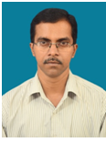
Shri. Bala Mandrekar
M.Com. M.L.I.SC. M.Phil. NET
It gives me an immense pleasure to place before you the first volume/issue of our college library News Letter PRAJNA. Narayan Zantye College of Commerce was established in the year 1994 and so as the library started functioning. Our library provides various facilities for the Students, Teaching faculty and Research Scholars with conducive environment for learning. The library is well lit and ventilated and has a collection of 16000+ Books, 68 Periodicals, 15 Newspapers, 286 CD’S/DVD’s etc. The college library is a member of UGC Inflibnet N-List Programme. Library provides e-library facility for students and faculty members where 20 computer systems are connectedwith internet via Broadband/Wi-Fi facility. Library operates from 8.00 a.m. to 5.00 p.m.

LIBRARY ADVISORY COMMITTEE

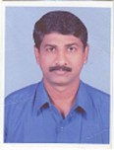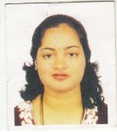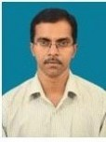
Prof. Pravin Sawant Prof. Anuradha Naik Shri. Bala Mandrekar
Chairperson Member Secretary

LIBRARY ORIENTATION PROGRAMME
The College academic year begin from 15th June 2016. The Librarian conducted the library orientation programme for the newly admitted students of F. Y. B. Com on 18th and 23rd June 2016 and for M. Com Part I on 26th July 2016. During the orientation programme, librarian gave the brief idea about the resources available in the library and services provided by the library and how to make best use of the available library resources and services and urged the students to make the optimum use of library.

Celebration of librarian’s day

The college library celebrated the Librarian’s Day on 12th August 2016 at the college seminar hall. Mrs. Poornima Kerkar, Lecturer at Dnyanprakash HSS., Mulgao, Bicholim was the Chief Guest for the Function. Library “Wall Paper” inaugurated at the hands of Chief Guest. The function started with the welcoming the Chief Guest by Library Committee Chairperson Assc. Prof. Pravin Sawant. The photo of the Father of Library Science Dr. S. R. Ranganathan was garlanded at the hands of Chief Guest. Principal Rajesh Amonkar Also Spoken on the needs of reading habits. Librarian Bala Mandrekar read the report of library and library activities. While delivering the Talk on “To Inculcate Reading Habit among Students” Mrs. Kerkar gave the examples of different authors such as A. P. J. Abdul Kalam, Sudha Murthy, Chetan Bhagat & alike and requested the students to read the books of these authors for personality development in their life. Through the Book Bank Scheme of our college the Books were distributed to the needy and deserving students at the hands of Chief Guest Mrs. Poornima Kerkar.112 students availed the facility of Book Bank scheme. Programme was compeered by Sayali Ranesardessai and vote of thanks proposed by Asst. Prof. Mrs. Anuradha Naik Bandiwadekar.
Celebration of Librarians Day and Book Bank Scheme Photos
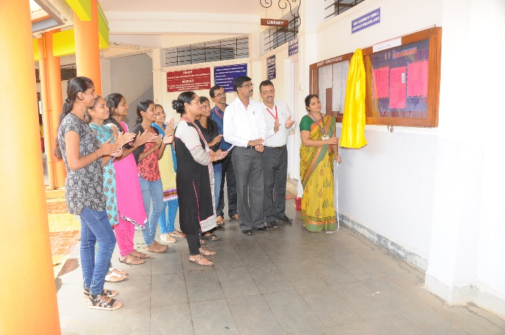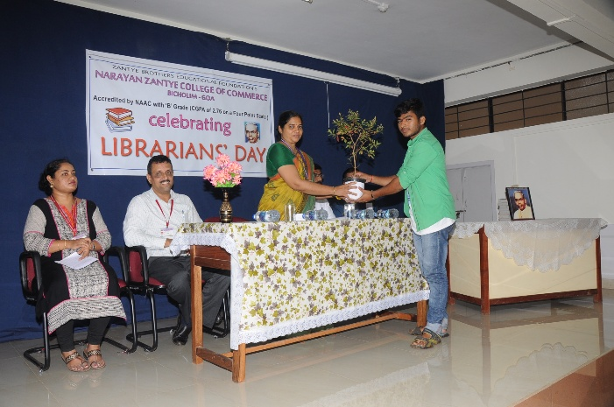
Wall Paper Inauguration Welcome to Chief Guest
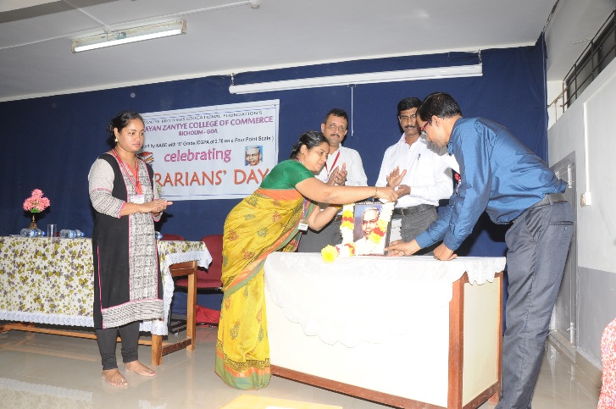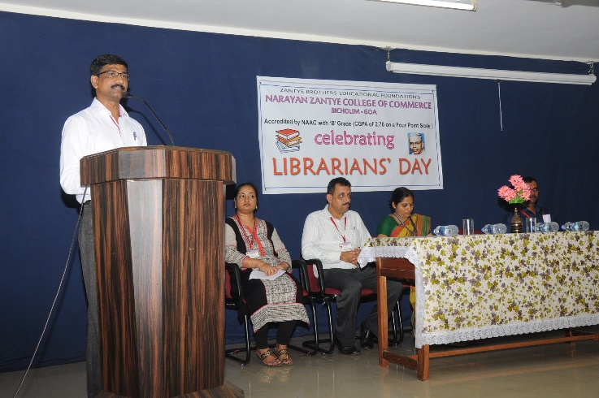
Garlanding the Photo of S. R. Ranganathan Welcome to Dignitaries

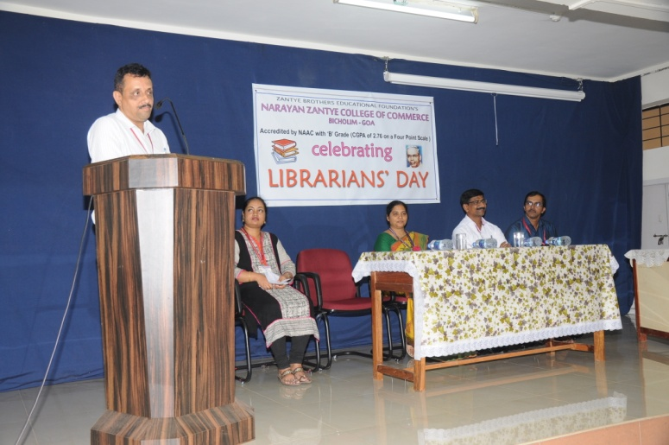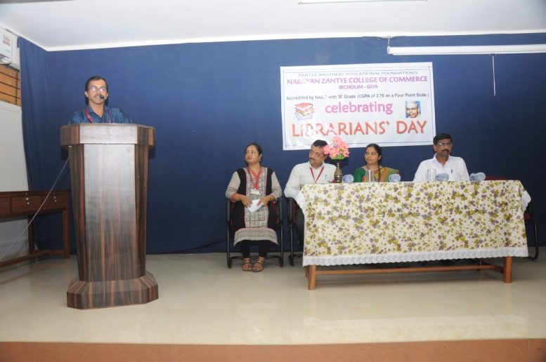
Principal Rajesh Amonkar Librarian Bala Mandrekar briefs about
Addressing the students the resources and services available in library

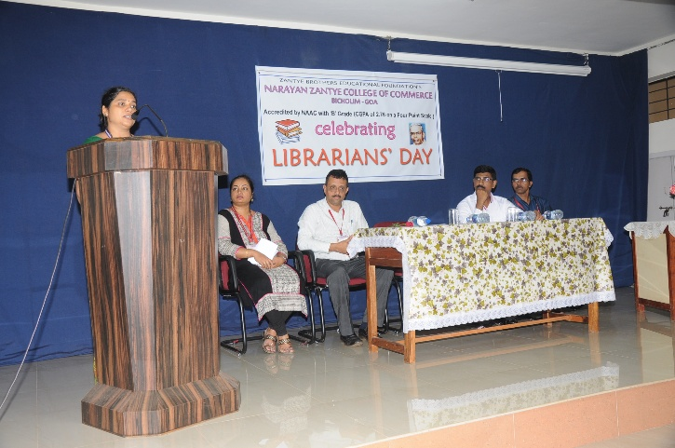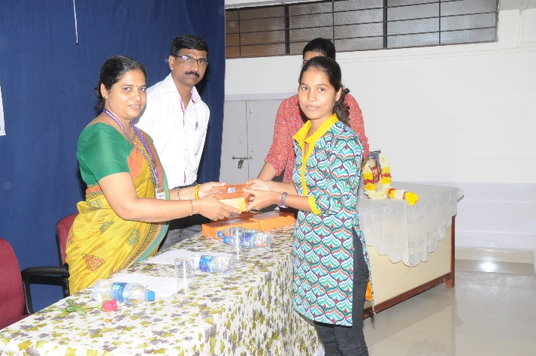
Chief Guest Mrs. Poornima kerkar Book Bank Recipient
delivering the talk on “Reading Habits”

LIBRARY STATISTICS
Total No. of Books: 15877
Periodicals: 68
Newspapers: 15
CD/DVD’s: 286
Projects: 341
Bound Volumes: 207
Goa Govt. Official Gazette.

Coming together is beginning, keeping together is progress, and working together is success – Henry Ford

